Variation unplugged
‘Variation’ is a current buzzword in maths in England, and is also a bunch of ideas that many people worldwide are using to think about maths teaching and learning. ‘Variation theory’ says that we learn when we are given a bunch of examples or experiences that are similar in some ways and different in others. We notice what varies (variation) when the background is not varying (invariant). In this writing I am pulling together perspectives on this from across the world. What matters is how you can use this to enhance teaching and learning – not the many terms that are growing around its use. It has come to prominence in England recently because of the Shanghai exchange projects and the focus on mastery as it is one of the words being used in that context. But many teachers here and some old textbooks used the ideas from way back. These questions have been around for years in maths teaching:
What’s the same? What’s different? What changes? What stays the same? If I change this thing, how does some other thing change? What is/what is not?
I am going to use two maths contexts from primary maths to illustrate how the word ‘variation’ might help to focus on learning and plan teaching. The contexts are (i) triangles and (ii) decimal place value.
Asking learners to show you an example of a triangle, or to tell you what a triangle is, tells you something about what they know about triangles. But what they draw or say might not be the whole story, so you might ask them to tell you more, or to draw a harder one, or you might push them a bit beyond the obvious.
Are these triangles? If so, why? If not, why not? What is/what is not?

Give me a number between 7 and 8; give me a number between 7 and 7.5; give me a number between 7.4 and 7.5 etc.
So you can use variation to find out and extend what they know, or the way they define things.
If we learn by sorting out our experiences and generalising from them – then the collection of examples we are given will ‘shape’ the way we understand things. Suppose the only triangles we have ever seen are more or less like these (off BBC bitesize).
So they all sit on a straight line base, and all point upwards, and all have names, and are all more or less the same sort of size, and the angles involved are a limited range. How does this limit learners knowledge of triangles? What variations would they have to experience to get a full understanding of triangles in a mathematical way? And how does this relate to the use of triangle outside mathematics (e.g. the musical instrument, the Winnersh triangle, triangular slave trade etc.) Drawing and transforming (varying) triangles using dynamic geometry software can extend their mental images of triangles – what changes and what stays the same? Thin/fat/small/big/ small angles/big angles/rotated etc.
Thinking about ‘what changes and what stays the same?’ can help to construct sets of examples that make it more likely that pupils will learn.
Think about what different ideas can be learnt in the following tasks:
- On a numberline, mark the points 0.1, 0.2, 0.3, 0.4 etc.
- On a numberline segment from 8.0 to 8.5, mark the points that cut it into tenths. Label them as decimals.
- On a numberline, mark the points: 0.7, (0.7 – 0.1), (0.7 – 0.2), (0.7 – 0.3), etc.
- On a tape measure, find the points 0.1 m, 0.2 m., 0.3 m. etc.
- On a numberline, zoom in and out to mark the points 4, 0.4, 0.04, 0.004, etc.
You can probably think of other variations of this kind of task. Each sequence can lead to different things to learn, some more interesting than others. Another kind of variation is to vary representations, e.g. what can be learnt from connecting/converting (from TES):
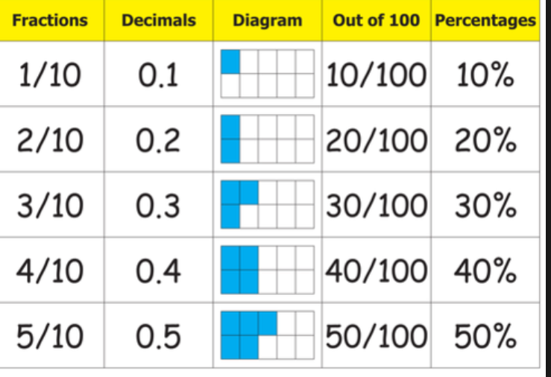
All these tasks tackle place value in some way, but all can lead to learning different aspects. All do this by offering some systematic variation so there is something to compare or contrast.
In the grid comparing fractions, decimals etc., on each row the proportion is invariant, the representation varies. In each column the representation is invariant, the value varies. You could ask learners to construct new rows for this, starting with different cells. Because they have some examples already that are carefully varied, they do not need to be told how to do this because they can reason about the ‘invariant relationships’ between representations, so if you give them, say 80%, they can work out and use a ‘rule’ for getting the other elements of a row. Try extending this beyond 100%. I say ‘invariant relationships’ because they are fundamental connections in mathematics, and they cannot change, and we can only get at them through examples and reasoning.
Here is a random page from a random online resource:
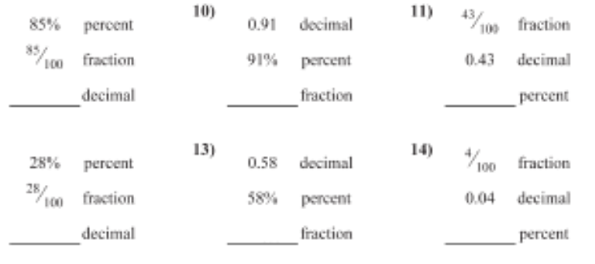
This page shows fairly random variety, not variation. It provides practice in conversion procedures, but not any new learning about decimal place value or the actual numbers involved, and can be completed mechanically by slapping double digit numbers down in various positions. Is there a way the questions could be put in a different order that would give pupils something to think about rather than only whether their answer is right or not? Could they also have a numberline representation? Or be asked to put answers in order of size? Are there any interesting connections between questions that can be used as discussion points? It is hard to imagine what conceptual learning could arise from this.
But such a resource might show up some difficulties that become the focus for the next teaching. For example, pupils’ answers to question 14 might make you suspect that they do not understand zero in the tenths place. This kind of fine-grained analysis of what pupils actually do is part of ‘variation theory’ because it gives you the raw material for future teaching.
Make ‘zero in the tenths place’ a focus for your next teaching and ask yourself ‘what needs to vary and what needs to stay the same for pupils to focus on zero in the tenths place when we are working to two decimal places?’
By contrast, the following set of examples unfolds a specific story about decimals, using variation (in place value) and invariants (the digits stay the same) to draw attention to relationships between powers of ten and decimal places. These can be done on a calculator and the patterns in the answers discussed. ‘Zero in the tenths place’ pops up as a feature during this exercise. Further digits can be included, e.g. use 42 instead of 4 to repeat the exercise. Discussion can include the language of tenths and hundredths etc.
4 x 100 = 4 ÷ 100 =
4 x 10 = 4 ÷ 10 =
4 x 1 = 4 ÷ 1 =
4 x 0.1 = 4 ÷ 0.1 =
4 x 0.01 = 4 ÷ 0.01 =
4 x 0.001 = 4 ÷ 0.001 =
A further variation would be to write all these as fractions, and as points on a numberline, or use a Gattegno chart to observe other relationships (see https://nrich.maths.org/10741).
Of course, once all this has been explored, discussed and represented in a range of ways, digits can be varied and pupils might them be ready for a random exercise if you still felt that one was necessary.
I hope this writing has made ‘variation’ sound more useful and less wordy – and I also imagine that you are probably saying ‘I do some of this already’.
A few key things: hang onto the useful questions listed above; hang onto the idea of taking a fine-grained idea such as ‘zero in the tenths place’ and using it as a teaching point, rather than a place for pupils to make errors; hang onto the idea of making variation and invariants work together to bring attention to such features; hang onto the idea that giving pupils limited examples leads to limited learning.

