Perimeters and Areas
John Mason
ATM London 2015

Coordinated Perimeters
See ppt for animation, or applet

More or Less Perimeter and Area
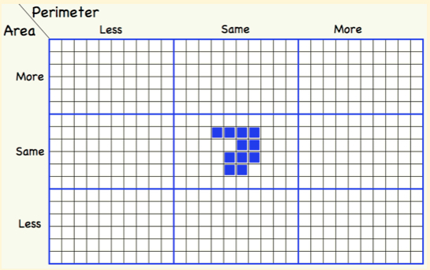 | Construct shapes that fit in the 8 cells, making as few changes to the central shape as possible.  Which cell was hardest to fill?  What have you learned about modifying shapes so as to change either the perimeter or the area but not both?

Shape Signature
The signature of a 2-D shape is the ratio of the square of the Semi-Perimeter to the Area
What is the signature of a circle?  What is the signature of a square? Of a rectangle?  What about 3-D? | If a shape is scaled, what happens to the signature?  Can different shapes have the same signature?
What are the signatures of your various shapes in the previous task?

Perimeter Adjustments
Compare the perimeters of the two shapes on the left (dotted lines show alignments). Construct other shapes whose perimeters can be worked out using only the lengths of the original rectangle.
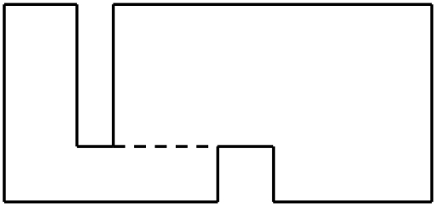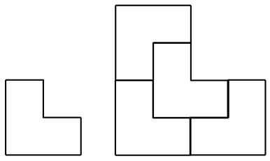

Scaling
On the right above are two shapes both of which can be scaled by a factor of two using four copies. What other shapes have this property? Can you find a shape that can be scaled by a factor of 3 using 9 copies but not by 2 using 4 copies?

Just Enough Information
Given a rectilinear figure such as shown in the middle above (all internal angles are 90° or 270°), now little information is needed so as to be able to calculate the perimeter? The area?

