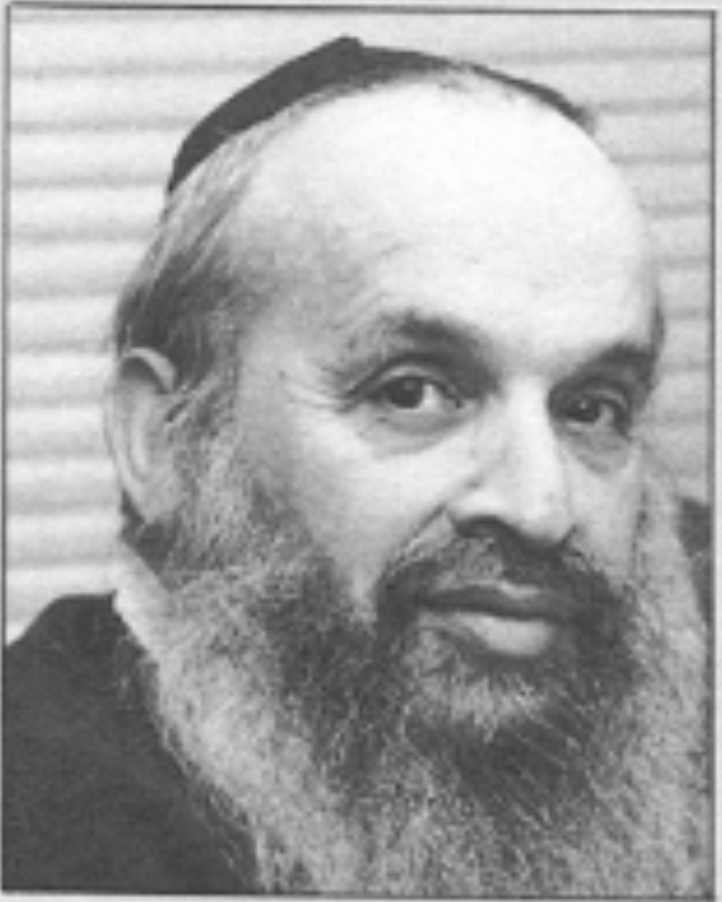

Maxim Memories
I was very fortunate to fall into a job under the leadership of Maxim Bruckheimer, who made a big difference in the development of my career. (I still see career in the sense of ‘careering out of control’!!).

First Encounter
It all began when, while in London prior to travelling around Europe, I realised that eventually I would need some income, and I noticed an advert for someone in “non-numerical computing”. I recognised each of the words, so decided to apply!
I went to the address in London only to find the doors wide open and the place deserted. They had that morning decamped to Milton Keynes. A few days later my wife and I drove to the mud-bath construction site which was emerging as the Open University campus. I tiptoed past the mud, followed a few corridors, and came to a door with the sign Mathematics Faculty on it. So I went in. At a desk by the window was an imposing woman sitting at a typewriter. I was just about to ask her where to go when this rather short man with a kippah came in and asked me what I wanted. I said that I was looking for the Dean, while looking over his head at the open door beyond him. “You’ve found him” was the reply. After a short conversation I filled out some forms and was given an interview date.
I showed up for the interview, involving Maxim, Ralph Smith, Norman Gower and by phone from Ireland, Mike Pengelly. There was a sequence of fairly routine questions until Maxim asked “how long will you stay?”. It was a reasonable question because I was obviously a North American travelling around Europe. I paused, and then said “as long as you’re happy with me, and I’m happy with you”. Shortly thereafter I received a contract, telling me simply the date on which I was to start, and the date on which I would retire, which was a bit off putting to a 25 year old! I lasted for 39.5 years, retiring on the specified date.

As Dean
Maxim could be fierce at times, though never with me, when people weren’t reaching his expectations, but mostly I remember the twinkle in his eye, the beaming countenance as he sailed above the tensions of initiating a brand new venture. For example, when he was in, his door was open, and anyone could drop in for a chat. More than that, when he had a decision to make that was either finely balanced or required consultation, he would cruise the corridor, dropping in to offices and asking our opinion. Since I was almost always in, I felt consulted and involved, a full member of the faculty from the beginning.
At first, course team meetings (for the foundation course) and faculty meetings were one and the same. I recall the moment when they were split, and for the first time started happening at different specified times. The Faculty and the Course Team were, in a sense ‘born’ at that moment. My dominant memory is of being reminded every so often that I was a colonial, and as such, I vaguely recall playing a mediating role when issues arose that could not easily be reconciled.

Designing Summer School;
After a month or two Maxim asked me to take over the design and running of the one-week summer school for the foundation course, based on the ideas of George Pólya. He knew that I had seen Pólya’s film, and had acted upon it in my teaching in Wisconsin. Among other things my new role meant that after the Vice-Chancellor had had dinner at some event with some other Vice-Chancellors, Maxim and I would be driven in a University car to some campus in order to appraise it as a possibility for one of our summer schools. Although I cannot remember specific details of what we discussed on those trips, I do remember being let in on issues arising in the wider university, and things that Maxim was currently concerned about. He invented the notion of Staff Tutors who organised local tutorials; he may have had a hand in inventing counsellors as well.

Maxim’s maxims
I remember full well Maxim railing against the “god uniformity” after attending university meetings at which policies were sought that would apply equally to all faculties. Indeed it came to be known as one of Maxim’s maxims, that “not all faculties are alike.” It was a real lesson in how ‘what is the same and what different’ depends on details: university committees seem dedicated to achieving a level of abstraction in which sameness is emphasised, ignoring or forgetting that differences in details mean actions are likely to differ, especially between different faculties. It is a mystery to me how efficiency is gained by merging the old faculties into new conglomerates, because of the differences in details of how different sciences operate.
Another of his maxims was that on the day when a draft was due, the draft was finished. He had little tolerance for handing things in late. When the first summer schools were about to begin, Maxim asked for a seminar on the design and the week’s programme, which seemed to me to go well. When I arrived at the first campus for the first week (I had staggered the starts so I could run the first week at each of three sites) I discovered that he had sent two senior faculty members to make sure everything went smoothly. They went home after a couple of days, as everything went smoothly. Maxim had trusted me all the way through the design and implementation, but felt the need to be absolutely sure. I resolved then and there to trust people to do what they said they would do, as an integral part of my own management style.

Pedagogy
Maxim’s structuralist view of mathematics is evident from the articles and books he wrote, many with his friend and colleague Don Mansfield, who later joined us as a consultant. His aim was often to support teachers in comprehending topics that were either newly inserted into the curriculum, or lay in the background foundations of topics already in the curriculum. The Open University provided a chance for Maxim and his team to take a structuralist, Bourbaki inspired but pedagogically informed approach to University mathematics, enabling thousands of people to succeed in mathematics who had struggled when at school. When I asked students at the summer schools why they were taking the foundation course, the reply was almost always “I struggled with maths at school, but always wanted to know more”.
Concluding paragraph to a critique of Bruckheimer & Mansfield (1966) about how to teach vectors (a new topic) in high school:
One must be careful not to be too categorical. There are principles in mathematical education but they must be thought of within the general framework of the structure of mathematics. It may well distort the picture if one example is seized with too much violence. This is an inherent danger in the present revolution. Many so-called new topics are being included in progressive syllabuses without integration into the general structure. They are presented in a very fragmentary fashion in much the same way that the traditional topics were. It would seem to the authors that beside the thought needed for the new topics themselves, much more thought must be given to this point of structure in mathematics. It is apparent from conversations with teachers from many schools that they have as yet very little idea of what mathematics lies behind the new syllabuses and topics, and for this reason, many are convinced that the new topics are just new gimmicks for a new generation. This is, perhaps, not entirely wrong but surely there is much more to be gained or lost than gimmickry.
Maxim’s contribution to teaching at Tertiary level was anything but gimmickry, showing how awareness of structure could be cast in a way that resonated with many students, enabling them to both appreciate and comprehend mathematical thinking.
Martyn Cundy quoting from Background to Set Theory
"If possible, one should not begin with the result and then provide the investigation. If one wishes one's students to react then one should present them with a reasonable problem suitably motivated, depending on their level, and not with the answer.”
[Their approach is] to explore a topic at the outset of each chapter, to develop it by means of Examples, many of which are left to the reader to work, to systematize what has thus been discovered, and then to suggest numerous Exercises which show the applications of the topic to familiar techniques.
Speaking of examples, over the years I have learned a great deal about exemplification in mathematics teaching and learning, and I have concluded that what really matters is attention: not only what is being attended to, but how.

References
Cundy, H. M. (1966). Review of Background to Set and Group Theory. The Mathematical Gazette. 50 (373) p322-323.
Bruckheimer, M. Gowar, N. & Scraton, R. E. (1968) Mathematics for Technology: a new approach. London: Catto & Windus
Bruckheimer, M. & Arcavi, A. (1995). A visual approach to some elementary number theory. The Mathematical Gazette. 79 (486) p471-478.
Mansfield, D. E. Thompson, D. & Bruckheimer, M. (1962). Mathematics: a new approach. London: Chatto & Windus.
Mansfield, D. E.. & Bruckheimer, M. (1965). Background To Set And Group Theory, Including Applications In The Teaching Of Mathematics. Chatto & Windus.
Mansfield, D. E. & Bruckheimer, M. (1965). Major Topics in Modern Mathematics. Harcourt, Brace & World
Mansfield, D. E. & Bruckheimer, M. (1966). Vectors: a special case? Math Gazette. 50 (372) p101-105.
Mansfield, D. E. & Bruckheimer, M. (1971). Modular Arithmetic: teachers’ book. Chatto & Windus.
Popp, W. & Bruckheimer, M. (1975). History of Mathematics: topics for schools (Student Library). London: Corgi.
Bruckheimer, M. & Steward, A. (1971). Sampling Inspection. London: HarperCollins.
Lietzmann, W. & Bruckheimer, M. (1965). London: Chatto & Windus.
Bruckheimer, M. (1960). Tensor Structures on a Differentiable Manifold. PhD Thesis (Southhampton).

