Dose of Don 3: Squares
This is the third of an irregular series of writings in which I (and, I hope, others) delve deeply into the collection of tasks on Don Steward’s blog https://donsteward.blogspot.com/ and pull out threads about key ideas in mathematics that run through several of his tasks. Where possible I give you a direct link to the tasks; where I have extracted part of a task I direct you to the ‘parent’ from which it came.
Don was very generous with his tasks and I hope that you will return this generosity in the way he requested before he died, namely to donate to https://www.justgiving.com/fundraising/jessesteward

In Dose of Don #2 I quoted a remark Don had made in his blog that ‘legitimately going from one statement to another (is kind of what maths is about)’ [his brackets]. It was said in the context of working with straight lines and linear expressions, so I decided to continue with squares as both geometric and algebraic objects. How does Don ‘legitimately go’ from one statement to another?
Squares as geometric objects have the properties of equal sides, right angled vertices, several kinds of symmetry and equal diagonals that bisect each other at right angles. Any of these properties can be expressed algebraically. Observation and measurement of components of squares can support deductive reasoning about other properties. For example, any straight line segment going through the point at which the diagonals intersect cuts the square in half by area. Area is a very useful feature of squares because it is the square of the side length (hence the similarity in the names) and that provides a bridge into meaningful algebra. But before I go over that bridge I will stay for a while with the equality of sides. If learners have internalised the reasoning power that depends on these equalities – the legitimate journeys from ‘these sides are equal’ to some less obvious statements – they are on the road towards mathematical reasoning. I propose that reasoning with squares based on their property of equal sides is good preparation for later geometric reasoning and a suitable arena for engaging in mathematics that is not primarily about calculation.
There are classic types of problem that can be solved using that property, see https://donsteward.blogspot.com/search/label/squares%20inside%20rectangles. The numbering of the squares indicates the length of the side.
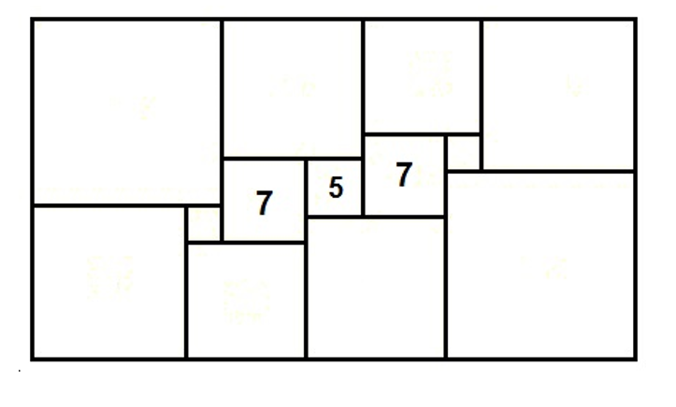
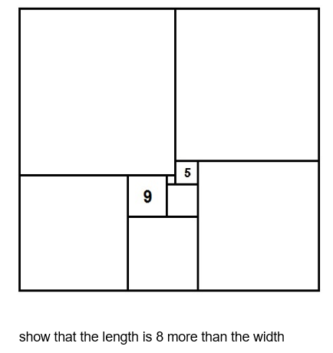
These two diagrams appear in his ‘number’ task sequence. Both of these depend on reasoning about equal sides. The lefthand diagram can be completed with verbal reasoning: ‘this must be … because …’. The right hand diagram is less straightforward: ‘if I knew this length, then I would also know that length’ and therefore needs algebra – the labelling of the unknown. It doesn’t even have to be a letter for younger learners, it could even be a coloured sticky dot to stand for an unknown value. It might be astonishing that many ‘square in rectangle’ problems can be resolved from very few initial measurements and the labelling of only one unknown.
Another version of the righthand diagram appears in the ‘equations’ task sequence on the same blog. This starts with the 7 and 28 being given. One feature of these puzzles is that a choice has to be made about which square to label as the unknown. In this diagram it is not the smallest that he has chosen to label as d. There is also some potential confusion about whether a length or a square has been labelled so you have to work through it to see what he was thinking. I have always thought it is important for learners to see someone else’s ‘work in progress’ so they understand that – yes - maths can be done messily and then it has to be tidied up to communicate it to others.
One interesting thing about this task sequence is that he called it ‘equations’ but there are no actual equations wrtten out, only expressions. Several ‘opposite side’ equations have been in his head in order to generate the expressions, and then the expressions can be gathered together and organised into equations from which the unknown will be found. Here, height can be expressed as 5d + (d + 7) and also as (42- d) + 28. Simpler examples are available.
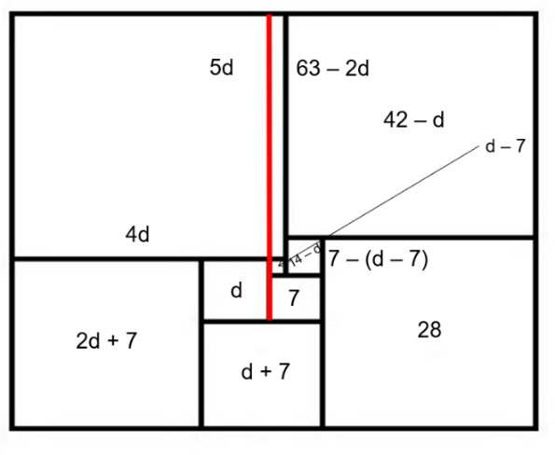
The algebraic manipulations that arise in these puzzles are purposeful and meaningful. In my view these problems do not need prior experience of gathering like terms or dealing with backets – they can themselves generate a need for these tools so could be a starting point rather than an end point of a ‘gathering terms’ teaching sequence.
Don offers a few simpler examples, and making them up takes a great deal of patience to ensure that solutions are always integers (there is no point in complicating matters with fractions when introducing deductive reasoning and algebraic formulation).
Let’s suppose learners have done several of these and become adept at ‘reasoning from the equality of sides’. Where can we go from here? For me an obvious direction is towards the use of area models – those two-dimensional representations of algebraic relationships that relate the word ‘square’ as a shape to the word ‘square’ as the second power. This model depends on the internalisation of equality of sides of a square, of the equality of opposite sides of a rectangle, and of expressing area of rectangles as the product of side lengths, which in squares gives x². I am not being patronising to list these, rather I am drawing attention to the need for learners to have internalised them not as verbally memorised facts but as components of the network of concepts that go with squares and rectangles. If they have to think hard to recall these they may not be in a suitable state to use such diagrammatic representations – they are the necessary tools for thinking.
So when and how does Don use area models? There is an example of his creative insight at https://donsteward.blogspot.com/2020/03/two-2-digit-multiplications.html which caught my eye. In this task sequence Don explores what happens when 35, 45, 55 … are squared. He asks the learner to work these out without a calculator and then hopes they will notice the appearance of 25 as the rightmost digits. The diagram he offers to explain this is:

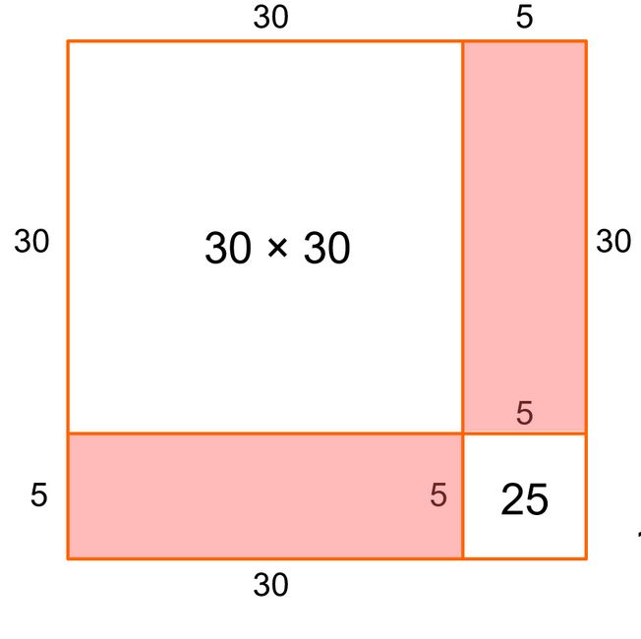

There is a sense in which the leftmost digits of the answer are out of the way of the ‘25’ because of … well why?
He then generalises this particular family of numbers to ‘10n + 5 squared’ showing that what is being represented by the diagram can also be represented, and calculated, by multiplying each term of the second bracket by each term of the first bracket and hence getting 100 as the coeffcient for both n and n². Why might we be interested in these rather special cases? One possible answer is the availability of suitable grid paper to facilitate the transformation between head and pencil-&-paper. Another possible reason is that Don the offers a further sequence about 31² and 31 x 29 which are represented as extensions of the use of area diagrams, and from which can be learnt something about the formation of the middle term of the polynomial format of a quadratic (other formats are available) and difference between two squares, and more, under the general heading of ‘a add b squared’: https://donsteward.blogspot.com/search/label/a%20add%20b%20squared.
As always, he leaves the progression up to the teacher, but I can’t help thinking that the presence of these tasks on his website means that he is favouring a meaningful, purposeful ‘slow burn’ approach to using and manipulating algebra by using spatial awareness. That would fit with his commitment to the ideas of Dina van Hiele who classified the components of mathematical understanding as: visualisation, analysis, abstraction, deduction and rigour. These are often regarded as hierarchical and indeed ‘seeing’ is a first response to a new bit of mathematics while imagination and imagery are key experiences of doing maths, not only features of good pedagogy. While the order might be hierarchical in terms of abstraction it is not herarchical in terms of learner-age. In my next ‘Dose of Don’ I will explore some more of his commitment to spatial reasoning.

