Sequence 7
New diagram.
Now I return to the three points called X,Y and Z created by the intersection of the Euler lines with the sides of the triangle in the Leeman-Gossard theorem. What if these were not associated with the Euler line but were any points X,Y and Z of your choice on BC, CA and AB. Is there anything interesting to be said? Yes. Construct circles through AYZ, BZX, CXY. They meet at a point called the Miquel Point (P) and the circles are Miquel circles for the triple X, Y, Z.
(Anything that now happens arising from these circles is also going to be true for the specific points X,Y,Z generated by the Euler line.)
Things to play with, observe, and maybe prove:
The centres of a set of Miquel(M) circles form a triangle similar to the original triangle.
The Miquel(M) point of a collinear triple of points lies on the circumcircle of ABC. If you extend yourtriangle sides you might notice that you now have 4 intersecting lines: AB, BA, CB and the line containing X,Y and Z
The centres of the M circles of a collinear triple and the circumcentre of the triangle lie on a further circle also passing through the M point.
Here is a completely different way to arrive at these ideas:
The circumcentres of the 4 triangles formed by 4 lines are concyclic, and the orthocentres are collinear.

The midpoints of the diagonals of a quadrilateral are collinear.

4 lines form 4 triangles whose circumcircles meet at a point. 5 lines form 10 triangles whose circumcentres meet in 4s at 5 points that lie on a circle….
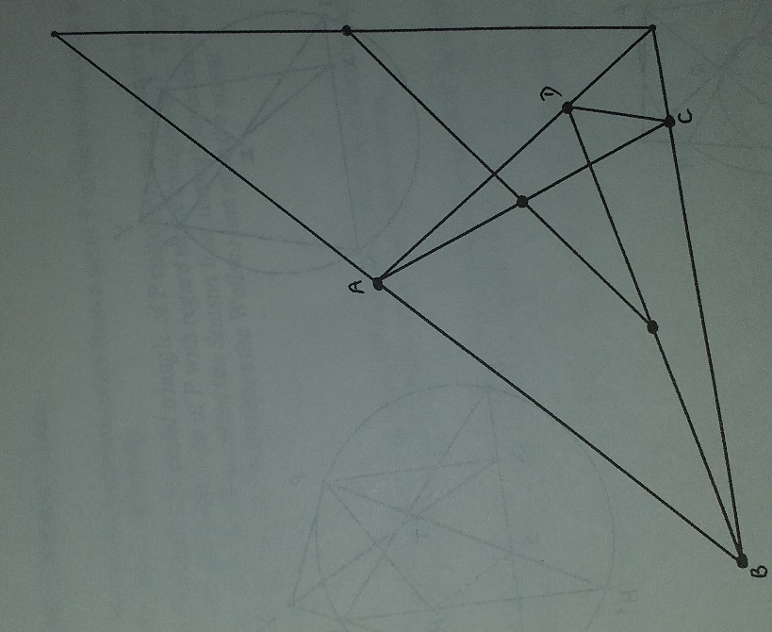

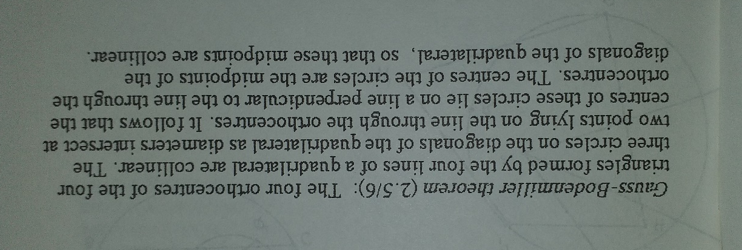

After this, if you want more, the first 6 parts of Dick’s original booklet are posted under ‘Dick’s triangle booklet’. The work in these sequences covers most of the first 4 parts but in a different order.

