Polynomials 3

Rational Polynomial Applet
John Mason
Jan 2014

Aims, Intentions & Possibilities
To become familiar with polynomial shapes and how they alter as the points that specify them change
To encounter Rational Polynomials
To experience reasoning about polynomials and their quotients
To encounter asymptotes

Varying
Imagine two polynomials which are specified by having the least degree and yet go through a specified set of points, as those points are moved.
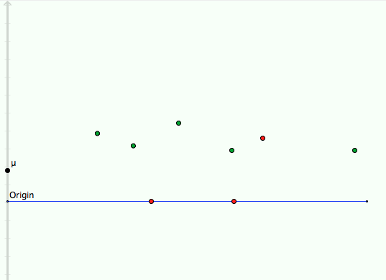
The three points (two on the axis) with one shading form the denominator; the other points specify the numerator.
How much of their behaviour can be predicted from these points?
What happens as one of the specifying points is varied a little?

Predicting
What will the quotient of the two polynomials look like? The quartic is the numerator, the quadratic is the denominator.
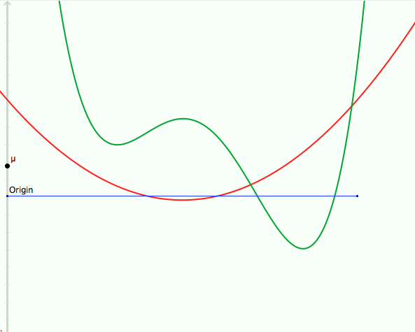
How much can be predicted about the quotient?

More Predicting
What happens as the denominator is adjusted so as to have a zero closer and closer to a zero of the numerator?

Applet
Up & Down Arrows: The degrees of the numerator and denominator can vary from 1 to 8 by clicking on the up and down arrows.
Locus Buttons: enable the polynomials showing to be tracked as locus of points by dragging the red point on the axis.
The origin can be dragged up and down to try to see ‘missing parts’ of a curve.
The μ-point adjusts the scale on the y-axis so as to get all principle features on the screen.

