Tasks from number workshop

Intro Task
Write down a number that uses lots of 9s; and another different one; and another different one
Task 1a:

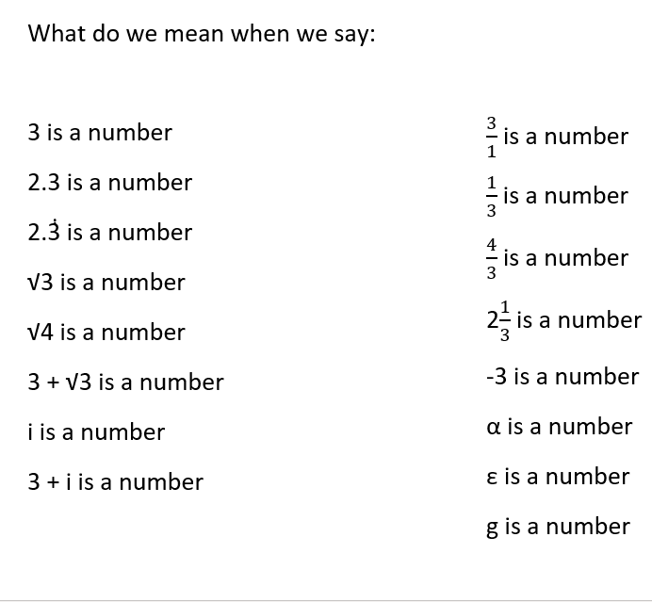
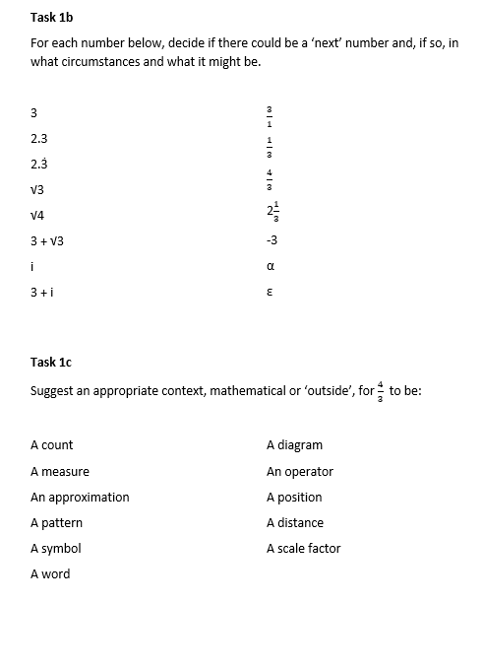
Tasks about multiplying and dividing numbers:

Task 3a: Don’s question: what has gone wrong?

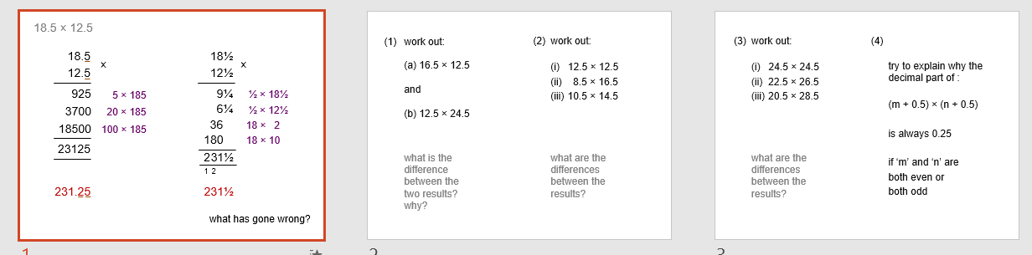

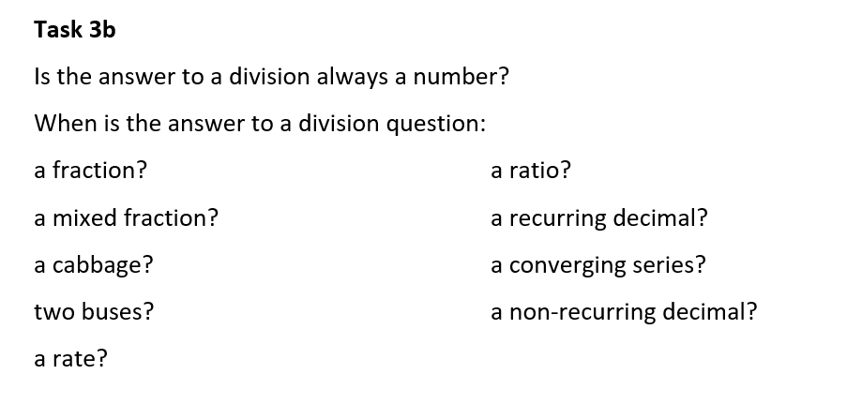
Integers (possibly from Don’s Median site):
