Dose of Don 4: Geometrical reasoning within constraints
This is the fourth of an irregular series of writings in which I (and, I hope, others) delve deeply into the collection of tasks on Don Steward’s blog https://donsteward.blogspot.com/ and pull out threads about key ideas in mathematics that run through several of his tasks. Where possible I give you a direct link to the tasks; where I have extracted part of a task I direct you to the ‘parent’ from which it came.
Don was very generous with his tasks and I hope that you will return this generosity in the way he requested before he died, namely to donate to https://www.justgiving.com/fundraising/jessesteward

Nichola Clarke’s DPhil research investigated the mathematical reasoning of students in lower attaining sets in upper secondary school. She found some students who were perfectly capable of ‘if … then … because…’ reasoning in geometrical situations but took ages to then calculate angles; they appeared to be struggling with reasoning when they were actually struggling with arithmetic. You might think that things would be different now that arithmetical fluency appears to have a higher profile in primary mathematics, but because the emphasis is sometimes on column methods instead of on recognising number bonds and relationships the same obstacles are likely to apply. Ori Golan had the insight, when first teaching geometrical proofs, that removing arithmetic by teaching algebraic and logical representation of angle relationships would fasttrack his students to reasoning rather than a dependence on calculating, and it did.
I didn’t have this in mind when looking for hidden threads in Don’s geometry resources but found it in his sequence of work on the regular dodecagon (confusingly posted under the heading ‘area’: https://donsteward.blogspot.com/search/label/area ). He had told me of the existence of this sequence, and made it available to participants of our workshop on angles (see pmtheta.com ‘PMTheta@home’ series) but my mind had been elsewhere and I did not pick up its potential significance. A superficial look shows pretty patterns and I thought of it as ‘how you apply angle-reasoning’ rather than as a sustained introduction to reasoning with angles.
His sequence is partly inspired by David Wells’ book: ‘Curious and Interesting Geometry’ but I cannot find that book to check what is in it (after Covid I will return to downsizing my library to passing visitors – but Wells seems to have already gone).
In several of his resources Don realised that working with a limited ‘palette’ of numbers would focus learners’ minds on relationships, properties and theorems rather than on calculation. In this case the palette involves 360, 180, 90, 45, 60, 30 and various multiples, sums and differences of these together with the idea that one revolution is 360° and the interior angle sum of a triangle is 180°. Even this list has some redundancies but you have to start somewhere. I found it useful to employ the ‘angle subtended at the centre of a circle by an arc is twice the size of the angle at the circumference subtended by the same, or a congruent, arc’ but this fact could also be deduced within the sequence.
Preparation for the sequence could consist of a significant time finding out ‘what numbers can be made from adding, subtracting, halving, doubling etc.?’ as a toolkit and sharing it as a public resource in a classroom. As with many number facts, it is useful to be so familiar with these that they can be recognised, e.g. ‘how might 120° be made?’ rather than seeking probable components with a calculator or p&p calculations.
OK, so armed with some familiar angle relationships what can be said about this?:
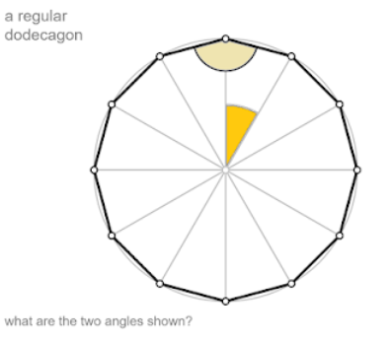
The more relationships you know about the more ways there are of answering this, but both can be deduced from the angles round a point, the angle sum for triangles, and symmetry. Other reasoning chains are possible of course, for example a turtle argument for an exterior angle would also be a good start. Anyone who has played successfully with the coding for ‘Frozen’ would have ways to think their way into this (https://studio.code.org/s/frozen ).
I would follow up with this inquiry:
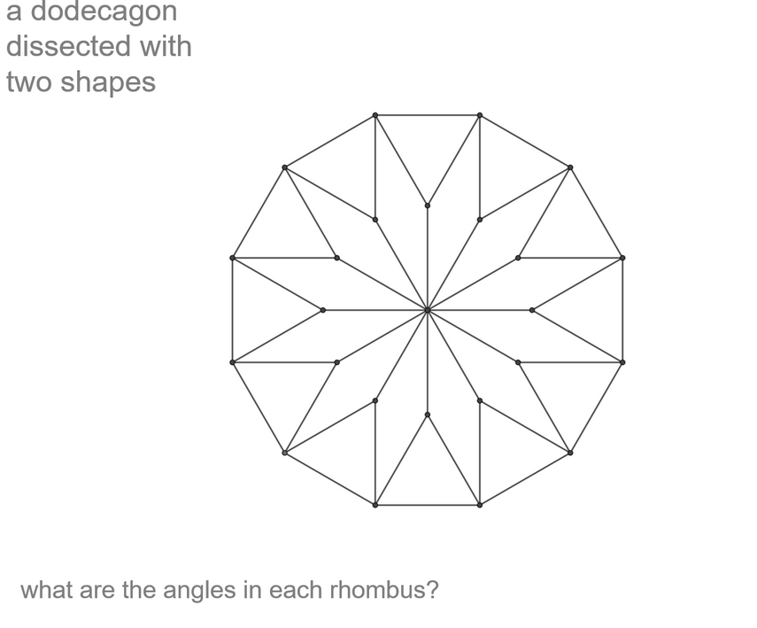
What are the minimum assumptions necessary to sort this diagram out? I am imagining a ‘facts board’ collecting the facts that are necessary and those discovered as they emerge from students’ work. I am afraid I cannot recall the name of a teacher who had a ‘conjecture’ list and a ‘proved’ list on show in the classroom for work such as this. Is it OK to use results that are only conjectures? Would a class-owned digital collection give the same availability for students to browse when they become stuck?
You might think me unadventurous in my choice of a second slide, given the goodies that Don has offered, but I am thinking that this second slide gives an opportunity to do some preparatory work on how chains of reasoning might be talked about and represented. These communication tools need to be established before moving on.

Here is a flavour of more complex slides:
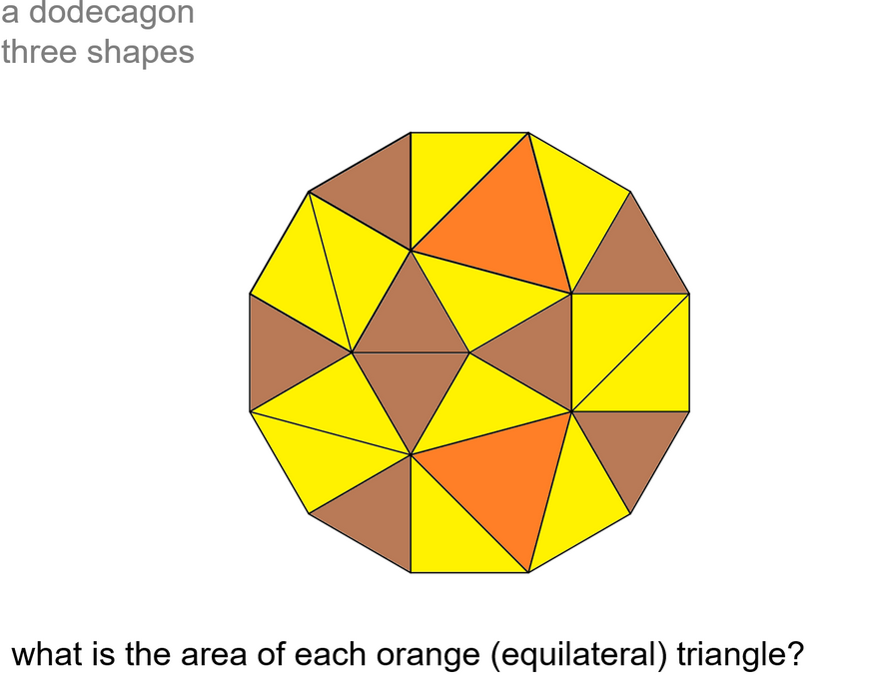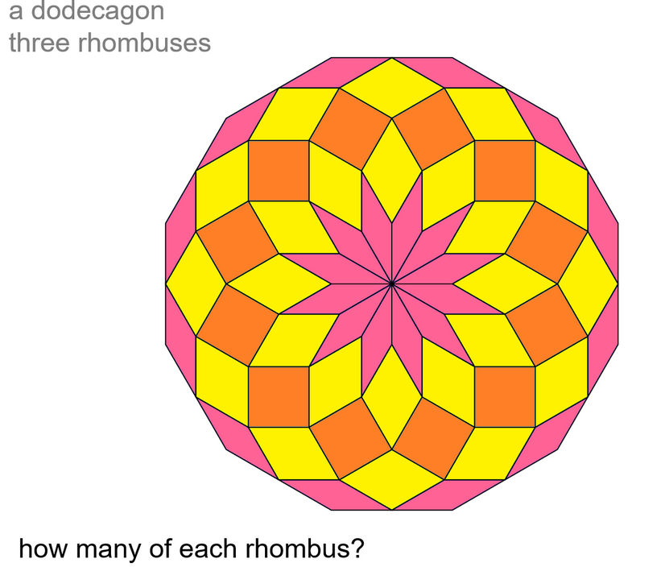
There are 47 slides in all for this sequence and I have worked through them, but am stuck on a couple. The central feature of my working was always the methods of reasoning; usually several pathways are available. Some of the reasoning uses general facts and geometry-theorem-development through reasoning about structure; some of the reasoning uses the specific properties of specific angles.
I presented the benefits of using a limited collection of numbers also in Dose of Don 1, in which I showed tasks where he had used grids to constrain the variation of angles, often represented by ratios.
But what I set out to do for this Dose of Don was look at area, and it was only because the above ideas had been posted under ‘area’ that I found them again. I had intended to collect some of Don’s ‘cutty-uppy’ tasks (otherwise known as proofs by dissection or proofs without words) to identify some of the thinking behind them. Conservation of area is a concept that most children arrive at when very young, and this sense is enhanced by playing with sets of 2-D shapes. Indeed, understanding of area as a concept is difficult since it is not such a lived experience as linear measure is (by moving things) or volume (by pouring things or trying to hide under chairs). In my experience, this is why many students grab onto a formula such as A = l x w for area questions, often incorrectly, instead of using conceptual understanding. Cutting paper shapes and moving them around builds on an intuitive idea of conservation and also provides content for ‘if … then … because …’ reasoning. I am afraid that watching shapes move on a screen does not give a sense of personal spatial manipulation. Deciding where to cut and move involves imagination plus reasoning; using dynamic geometry software limits these decisions to those that are conventionally and geometrically useful, such as using mid-points, perpendiculars, and so on; origami offers a palette of useful outcomes that can be achieved by folding. Watching someone else, or a prepared animation, pre-decides the moves.
I find that with some of Don’s ideas I have to distinguish between what can be used for initial learning, what for the development of ideas through sequences of examples that draw attention to characteristics or complexify those ideas, and what for application and extension to other ideas. I am offering some that can be used for initial learning about area of certain shapes alongside using manipulation as an exploratory tool.
Consider this question, which appears to be about the area of triangles but only needs the concept of conservation of area. Don offers eight different proofs in https://donsteward.blogspot.com/2016/03/quartering-parallelogram.html and I am particularly interested in those that build on a cutty-uppy approach:
Note how the final proof that I have selected labels angles to transform a cutty-uppy approach into the use of congruence because certain kinds of movement also conserve angles. To know that congruence is not only about angles and sides but also area (therefore) seems to be a relevant fact. Can you find this explicitly in a school textbook?
Can congruence be deduced from the equality of one side, of one corresponding angle, and of area? Ditto two pairs of equal angles plus area? And so on.
Don provides a sequence about the area of a rhombus from an initial idea to one of the possible algebraic representations in https://donsteward.blogspot.com/search/label/area%20of%20a%20rhombus . The sequence uses cutty-uppy with constraints by limiting the exploration to a square-dotted grid.

I shall leave the algebraic development to readers.

